**Resolving Merge Conflicts**

Let’s create a new repository, and ensure that the new repo’s main branch is in clean state

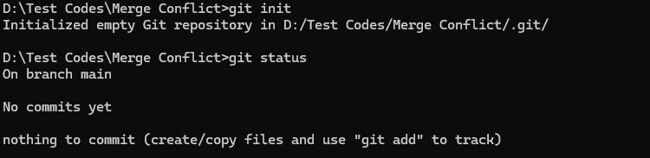

Let’s create a file in the main branch and add some contents into it.

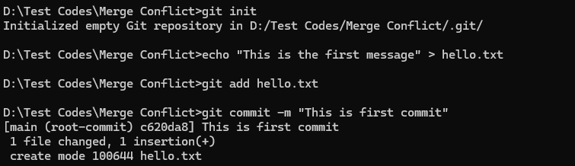

Now, Let’s create a new branch and change the hello.txt file

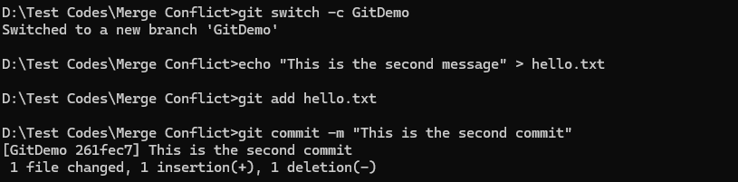

Let’s switch back to main, and change the file again.

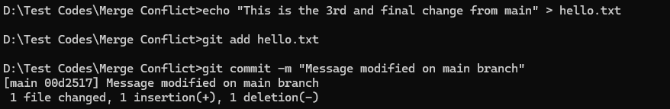

Now, Let’s observe the git tree.

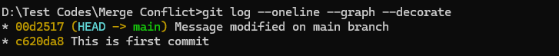

Using git diff

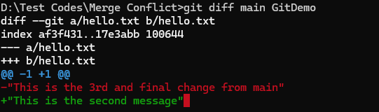

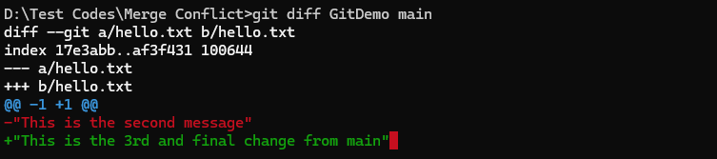

Let’s try to merge it. (For convenience, I’m using VS Code)

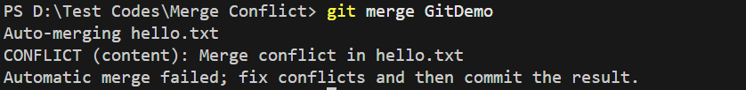

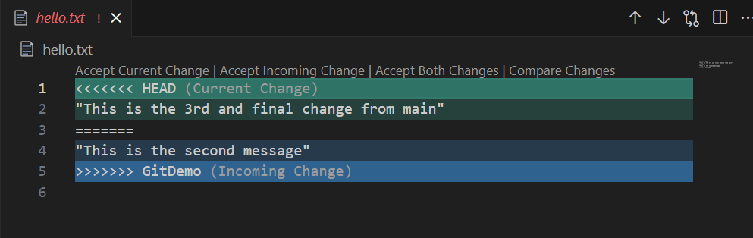

Let’s resolve this conflict by including both changes in the file.

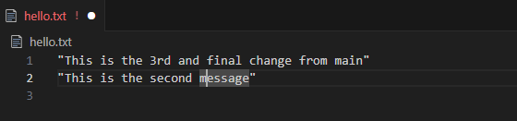

Let’s add and commit the file and check the status. We can also delete the merged branch “GitDemo”





